**Advanced Task 2**

**Design Datawarehouse & Build SSIS Package**

**Data Warehouse Design:**

9. Add DimState with DWStateKey,StateCode and StateName

SSIS package:

FactProperty FactRentalMedian

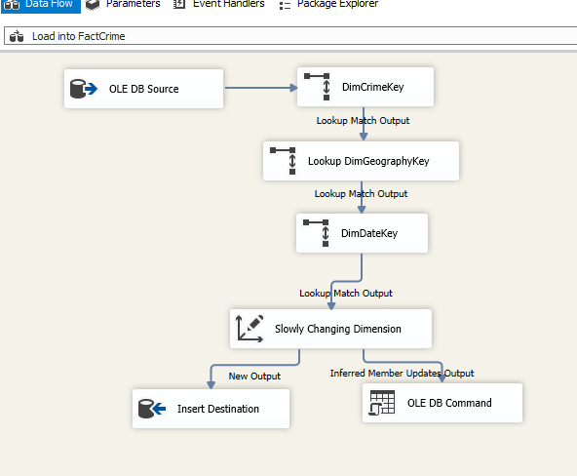

FactCrime

7. Using Suburb and City Dataset, design a Dim table - DimGeography with State / City / District / Postcode / Suburb / Lon / Lat,

8. DimTransport: Load public transport data to StgTransport table

10. Design DimAuLocalSchool tables for Aus local school

11. Design FactCrimeByYear

DimCrime

FactCrimeByYear

12. Design FactSuburbRentalMedian

DimRentalMedian

FactSuburbRentalMedian

13. Design Fact table – FactMedianPropertyValueByYear

DimPropertyMedian

FactMedianPropertyValueByYear

